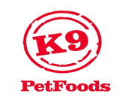
K9 FREE FLOW MINCE 15kg
NOT INTENDED FOR HUMAN CONSUMPTION
PET FOOD ONLY
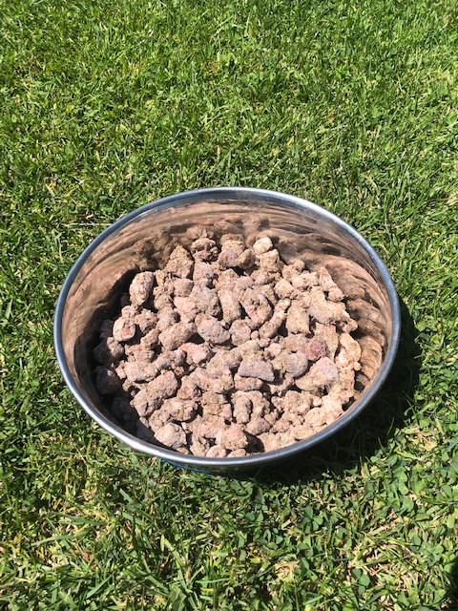
INGREDIENT LISTING: Meat & Meat by products derived from Lamb, Beef & Fish, Wholegrain cereal & garlic.
80% Meat, 15% Meat Blood & Fish Meal, 5% Wholegrain cereal.

TYPICAL ANALYSIS: Crude Protein 25%, Crude Fat 19%, Crude Fibre 1%, Carbohydrate 3%, Energy 1190kj/100g

SUGGESTED DAILY FEEDING GUIDE:
Size of Dog Grams Cups
Up to 10kg 60 - 250 ½ - 2
10-20kg 250 - 500 2 - 4
20-40kg 500 - 750 4 - 6
Over 40kg 750 + 6 +

Meal servings are approximate and the amount of food your dog requires will vary depending on their age, size, breed, activity level and condition.
Always have clean, fresh water available at all times.

Manufactured by: K9 Petfoods Hastings, www.k9petfoods.net - PF152

